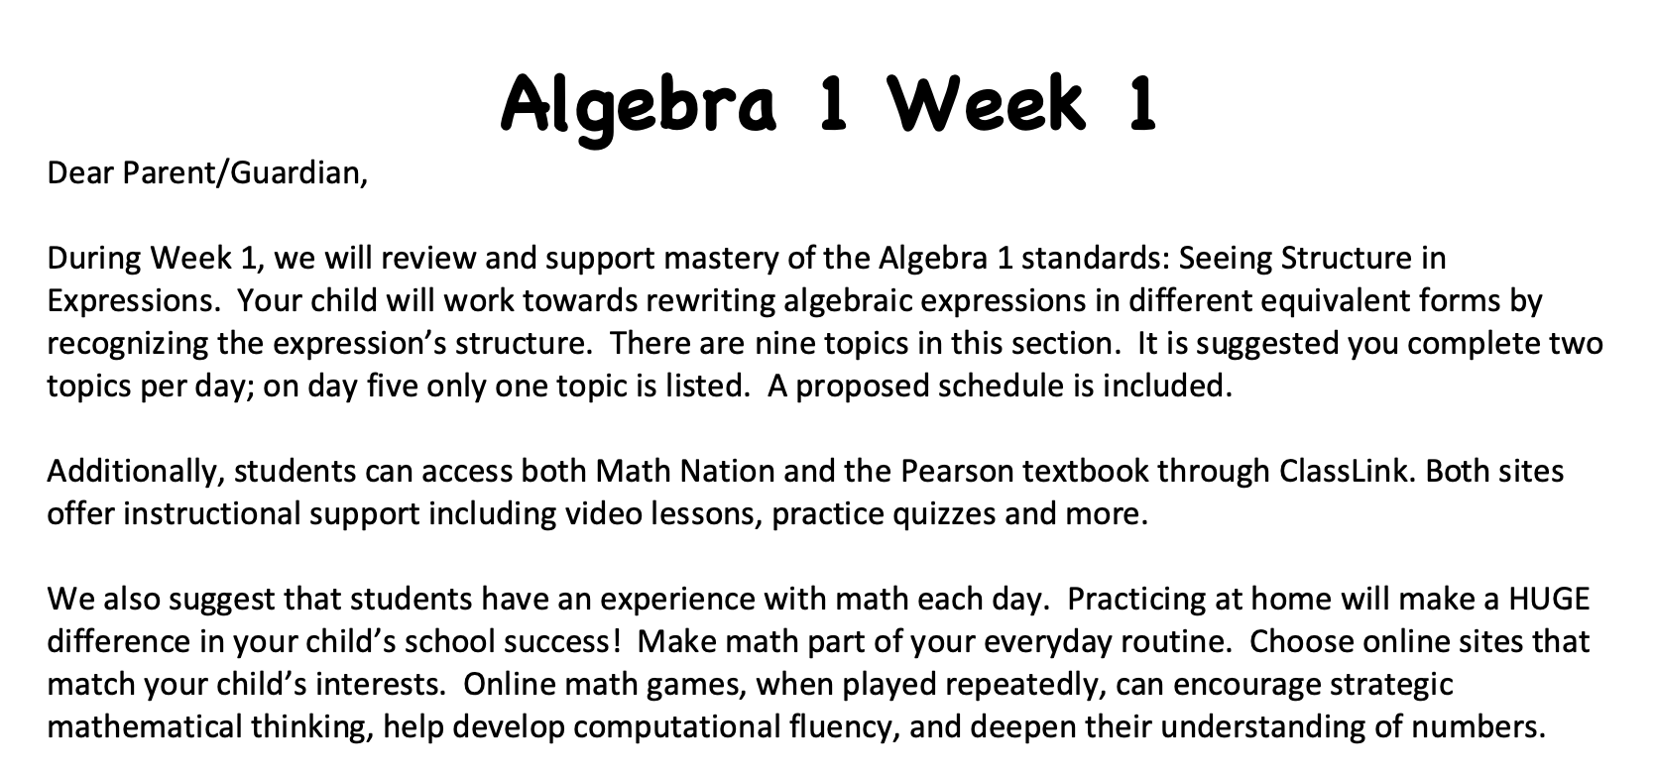
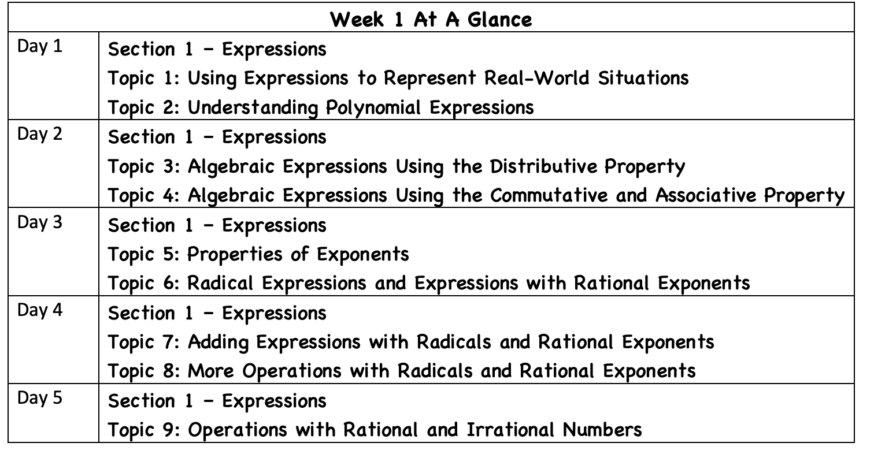

Name ___________________________________________ Date_______________

Expressions

Section 1 – Topic 1: Using Expressions to Represent Real-World Situations

Independent Practice

- Write each phrase as a mathematical expression.

Phrase | Mathematical Expression
nine increased by a number
fourteen decreased by a number
seven less than a number
the product of nine and a number
thirty-two divided by a number
five more than twice a number
the product of a number and six
seven divided by twice a number
three times a number decreased by eleven
withdrawing $\$10$ every week from an outstanding balance of $\$400$

- Joseph tweets 1$3$ times a day. Define each variable and write an algebraic expression to describe the number of posts after any given number of days

- Emanuel has $745$ pictures in his phone. His memory is getting full, so he starts deleting $20$ pictures every day. Define each variable and write an algebraic expression to describe the number of pictures left on his phone after any given number of days.

- Ashley posts $17$ status updates on her Facebook wall each day. Roberto posts $21$ status updates on his Facebook wall each day.

Part A: Define each variable and write an algebraic expression to describe the combined number of posts for Ashley and Roberto after any given number of days.

Part B: Write an algebraic expression to describe the difference between number of posts for Ashley and Roberto after any given number of days.

- Tommy posts $11$ pictures on Instagram every day. Elizabeth posts $15$ pictures on Instagram every day.

Part A: Define each variable and write an algebraic expression to describe the combined number of posts for Tommy and Elizabeth after any given number of days.

Part B: After $7$ days, how many pictures have Tommy and Elizabeth posted altogether? How do you know?

- Homer and Bart plan to buy one computer for $\$499.00$ strictly for gaming purposes. Games cost $\$49.99$ each.

Part A: Define each variable and write an algebraic expression to describe how much they will spend before sales tax, based on purchasing the computer and the number of games.

Part B: If they purchase one computer and five games, how much do they spend before sales tax?

Part C: Homer and Bart have friends. They want to purchase extra controllers. Each controller costs$\$24.99$. Use an algebraic expression to describe how much they spend in total, before sales tax, when they purchase one computer, any number of games, and any number of extra controllers.

Part D: What would be the total cost, before sales tax, if Homer and Bart purchase one computer, four games, and three extra controllers?

- Alex and Leandro purchase two matinee movie tickets. A matinee ticket costs $\$6.50$, a drink costs $\$5.50$, and a bag of popcorn costs $\$6.00$. Define each variable and write an algebraic expression to describe how much they spend based on the number of drinks and bags of popcorn they buy. Identify the parts of the expression by underlining the coefficient(s), circling the constant(s), and drawing a box around the variable(s).

- The local humane society is restocking on cat food to prepare for kitten season. Very young kittens need kitten formula which costs $\$3.99$ per bottle. Older kittens need wet cat food which costs $\$1.50$ per can.

Part A: Write an algebraic expression to describe how much the humane society will spend on kitten supplies. Identify the parts of the expression by underlining the coefficient(s), circling the constant(s), and drawing a box around the variable(s).

Part B: How much money (before tax) will the humane society spend if they buy $30$ bottles of kitten formula and $120$cans of wet cat food?

Part C: If you add a $7\%$ sales tax to the purchase of bottles of kitten formula and cans of wet cat food, how would the algebraic expression used in parts A and B change?

- Create a storyline (word problem) using the following algebraic expressions:

Part A: $\frac{1,000}{r}$

Part B: $75-3m$

Part C: $30+2d$

- An airplane is flying at $35,000$ feet above sea level. The airplane starts to descend at a rate of $2,500$feet per minute. Let $m$ be the number of minutes. Which of the following expressions describe the the height of the airplane after any given number of minutes?

- $2,500-35,000m$
- $2,500+35,000m$
- $35,000-2,500m$
- $35,000+2,500m$

Section 1: Topic 2 - Understanding Polynomial Expressions

Independent Practice

- Write $9x+{3x}^{2}-{4x}^{5}+{x }^{3}+{2x}^{4}$ in standard form.

- Determine the type and degree of each of the following polynomial expressions.

$$9x^{4}y^{9}$$

$$x^{4}-3x^{2}+7x^{5}$$

$$19a^{6}b^{2}+8ab^{3}c-27a^{7}$$

- Consider the following polynomial expression: $4x^{5}-16x^{2}+13x^{8}$.

Part A: Write the polynomial expression in standard form.

Part B: What is the degree of the polynomial?

Part C: How many terms are in the polynomial?

Part D: What is the leading term?

Part E: What is the leading coefficient?

- Match the polynomial in the left column with its descriptive feature in the right column.

A. $x^{3}+3x^{2}-2x+7$ I. 9th degree monomial
B. $3a^{3}b^{6}$ II. Constant term of $-7$
C. $3x^{4}-9x^{3}+5x^{8}$ III. 7th degree polynomial
D. $7a^{3}b^{2}+18ab^{2}c-9a^{3}$ IV. Leading coefficient of $4$
E. ${2x}^{5}-9x^{3}+8x^{7}$ V. Four terms
F. $4x^{8}-7x^{2}+9$ VI. 5th degree polynomial
G. $x^{2}-7$ VII. Equivalent to $5x^{8}+3x^{4}-9x^{3}$

- Write a binomial expression in standard form that has a degree of 4.

- Write a trinomial expression in standard form that has a degree of 5.

- Janae wrote the following polynomial expression: $2x^{5}-4x^{3}+6x^{8}$. Janae claimed it was a trinomial with a leading coefficient of $2$. Justin argued back claiming that it was a trinomial with a leading coefficient of$6$. Who is correct? Explain.

- Ladarius wrote the following monomial expression: $5x^{8}y^{3}$. Ladarius said the monomial had a degree of $11$. Ayla said the monomial had a degree of $8$. Who is correct? Explain.

Section 1 : Topic 3 - Algebraic Expressions Using the Distributive Property

Independent Practice

- Match each expression in the left column to its equivalent expression in the right column. Use the table in the right to write the letters that corresponds to each of the numbers.
1
2
3
4
5
6
7
8

1. $7\left(12\right)$ | A. $5(1+3a)$
2. $3(15)$ | B. $3(a+3)$
3. $3a+9$ | C. $3(x+y+z)$
4. $9a+3$ | D. $7(8+4)$
5. $5+15a$ | E. $3(x+2y+3z)$
6. $10+5a$ | F. $5(2+a)$
7. $3x+6y+9z$ | G. $3(3a+1)$
8. $3x+3y+3z$ | H. $(2+1)(15)$

- Write an equivalent expression for $4\left(a+5\right)$ by modeling and by using the distributive property.

- Write an equivalent expression for $5(2x+y-3z)$ by modeling and by using the distributive property.

- Write an equivalent expression for $(x-6)(x-3)$ by using the distributive property and by modeling.

- Write an equivalent expression for $\left(2m+3\right)\left(m-1\right).$

- The recommended heart rate for weight management exercise and improving cardio fitness, in beats per minute, depends on a person’s age and can be represented by the expression$0.7(220 – a)$.

Part A: What does the variable in the expression represent?

Part B: Rewrite the expression using the Distributive Property.

Part C: What is the recommended heart rate for a 20-year-old person?

- Coach Smith is buying equipment for his soccer team. He has $11$ players and each player needs three uniforms, two shin guards, one ball, and two pairs of cleats.

Part A: Write an algebraic expression to represent this situation.

Part B: If each uniform costs $\$48.00$, each shin guard costs $\$5.00$, each ball costs $\$17.00$, and each pair of cleats costs $\$89.00$, determine how much Coach Smith will spend, before taxes, on equipment for his soccer team.

- Logan is building a game room adjacent to his living room so that both rooms will have the same width. He created a model on a piece of paper as shown below:
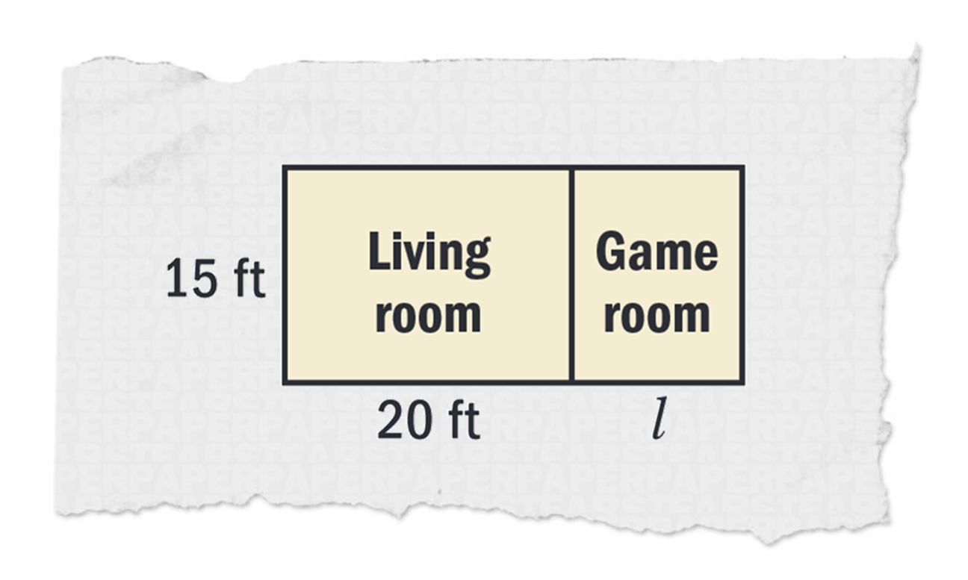
Part A: Write an expression for the total area of both rooms by using the distributive property.

Part B: If the length of the game room is 15 feet, what is the total square footage of the two rooms?

- The state of Maine encourages recycling by giving refunds for certain recycled items. When you recycle a glass bottle, you get back $\$0.05$, when you recycle an aluminum can, you get back $\$0.10$, and when you recycle a plastic bottle, you get back $\$0.15$.
Part A: Drinks in a glass bottle cost $\$2.00$, drinks in an aluminum can cost$\$0.50$, and drinks in a plastic bottle cost $\$1.50$. You plan to purchase two of each. Use the distributive property to write an expression that represents the amount of money you will spend.

Part B: You plan to recycle all of the items you purchased. Use the distributive property to write an expression to represent the amount of refund you will receive.

Part C: After receiving the refund, how much was your net cost for the items.
Hint: Net cost is equal to the total cost minus the amount of your refund.

- Suppose you are building a rectangular pen for your goats. You use $400$feet of fencing for the pen. Let $l$represent the pen’s length (in feet).

Part A: Which of the following expressions could represent the width of the pen?

- $2l+400$
- $400-2l$
- $2l-400$
- $400(2l)$

Part B: Find the width of the pen if you make the pen $80$ feet long.

Part C: Find the width and the area of the pen if the length is$90$ feet.

Section 1: Topic 4 - Algebraic Expressions Using the Commutative and Associative Properties

Independent Practice

- Identify the property used to find the equivalent expression.
$[4+\left(-2\right)]+1 = 4+[(-2)+1]$ $(9∙3)∙6 =6∙(9∙3)$

$(a × 3) × b = b × (a × 3)$ $x+(y+z)=(x+y)+z$

$2 × \left(p × q\right)= \left(q × p\right) × 2$ $(8+17)+18=18+(17+8)$

- The following is a proof that shows $(5p)(4q)$ is equivalent to $20pq$. Fill in each blank with either “Commutative Property” or “Associative Property” to indicate the property being used.

$\left(5p\right)(4q)$ = $5\left(p∙4\right)q$ ________________________
= $5\left(4∙p\right)q$ ________________________
= $(5∙4)(p∙q)$ ________________________
= $20pq$

- Write a mathematical proof to show $\left(3x\right)\left(5y\right)(7z)$ is equivalent to $105xyz$.

- Identify which of the following properties are being used in each step below.
Associative Property Commutative Property Distributive Property

$\left(4+7\right)\left(m^{2}+n^{2}\right)$ =$4\left(m^{2}+n^{2}\right)+7\left(m^{2}+n^{2}\right)$
= ${4m}^{2}+4n^{2}+{7m}^{2}+{7n}^{2}$
= ${4m}^{2}+{7m}^{2}+4n^{2}+{7n}^{2}$
= $11m^{2}+11n^{2}$

- Write an equivalent expression using the given property.

Part A: Commutative property of multiplication

$$3xy=$$

Part B: Associative property of addition

$$x+y+z=$$

Part C: Distributive property

$$3x\left(y-2\right)=$$

- Use these abbreviations for the properties of real numbers and complete the flow diagram.
$C_{+}$ for the commutative property of addition
$C_{×}$for the commutative property of multiplication
$A_{+}$ for the associative property of addition
$A_{×}$ for the associative property of multiplication
$D$ for the distributive property

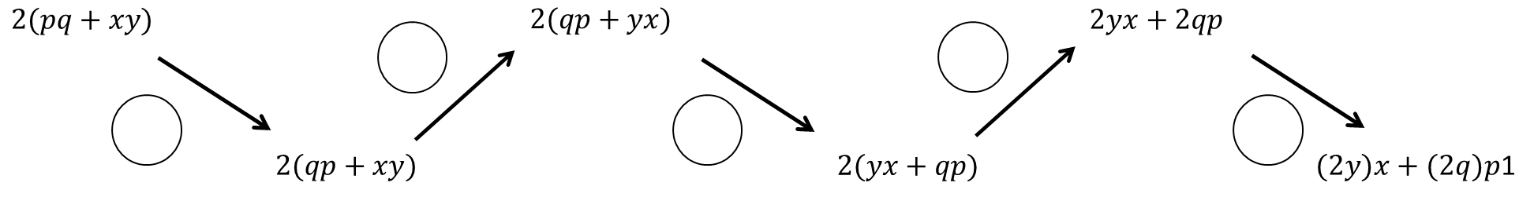

- If $pq=23$ and $uv=\frac{1}{23}$ , find the value of $u∙q∙v∙p$. Explain which properties you used.

- Consider the expressions $ab^{2}$ and $a^{2}b^{2}$. Are the two expressions equivalent? Which properties did you use to prove or disprove equivalency?

Section 1: Topic 5 - Properties of Exponents

Independent Practice

- Simplify the following expressions:

Part A: $\frac{2x^{3}y^{3}}{4y^{2}}=$

Part B: ${\left(\frac{x^{-8}}{y^{11}}\right)}^{-2}=$

Part C: $\frac{\left(2x^{3}\right){\left(x^{4}\right)}^{2}}{8x^{11}}=$

- Your neighbor has a square-shaped pool with side lengths of $3a^{5}$. What is the area of the pool?

- Bojangles has a rectangular-shaped roof with a width of ${6x}^{2}$ feet and a length ${12x}^{3}$. What is the area of the roof?

- Consider each equation. Find the value of $m$ in each equation below. Justify your answer.

$${\left(x^{m}∙x^{2}\right)}^{3}{\left(k^{3}\right)}^{5}=x^{21}k^{15}$$

$$x^{3}∙y^{2}\left(\frac{x^{2}∙y^{3}∙z^{m}}{z^{-5}}\right)=x^{5}y^{5}z$$

$${\left(\frac{x^{8}}{yz^{5}}\right)}^{m}=1$$

- John buys a water tank from a company that likes to use exponents as dimensions. The tank he buys has the dimensions $b^{2}$ by $b^{4}$ by ${4c}^{3}$. Which of the following expressions represent the volume of the water tank?

- $4b^{8}c^{3}$
- $4b^{6}c^{3}$
- $12b^{8}c^{3}$
- $2b^{6}c^{3}$

- The dimensions of Peyton and Parker’s sandbox are $t^{2}$m by $t^{5}$ m by ${3v}^{2}$ m. One cubic meter of the sandbox contains ${3s}^{21}$ grains of sand. Which of the following expressions represent the amount of grains of sand in the sandbox?

- $27t^{10}v^{2}s^{21}$
- $t^{10}v^{2}s^{21}$
- $3t^{7}v^{2}s^{21}$
- $9t^{7}v^{2}s^{21}$

- Consider the equation $a^{-3}={\left(\frac{1}{a}\right)}^{5}$.

What value(s) of $a$ make the equation true?

- Harry, Louis and Niall are working with exponents. Harry claims $4^{2}∙4^{5}=4^{10}.$ Louis claims $4^{2}∙4^{5}=4^{7}$. Niall claims $4^{2}∙4^{5}={16}^{7}$. Which student has the correct answer? Explain why.

- Raymond and Rose were working with exponents.

Part A: Raymond claims that 5⁵ * 5² = 5³. Rose argues that 5⁵ * 5² = 5⁷. Which one of them is correct? Use the properties of exponents to justify your answer.

Part B: Raymond claims that 7⁹/7⁵ = 7⁴. Rose argues that 7⁹/7⁵=7⁴⁵. Which one of them is correct? Use the properties of exponents to justify your answer.

Section 1: Topic 6 - Radical Expressions and Expressions with Rational Exponents

Independent Practice

- The following expression shows a simplification of a radical with a missing index.

$$\sqrt[n]{54∙x^{6}∙y^{12}=}3x^{2}y^{4}\sqrt[n]{2}$$

What is the index $n$ for this expression?

- $2$
- $3$
- $6$
- $9$

- Simplify the expression, ${\left({\left(p^{-2}+\frac{1}{p}\right)}^{1}\right)}^{p}$, when $p=\frac{3}{4}$, in both radical and rational exponents forms.

Radical form:

Rational exponent form:

- Write an equivalent expression in rational exponent form:

$\sqrt[8]{5^{6}}$

$\sqrt[4]{x^{\frac{2}{3}}}$

$\sqrt[3]{8}\left(\sqrt{8^{2}+8^{2}}\right)$

- Determine the value of $n$ such that $\sqrt[4]{{64}^{\frac{1}{3}}}={64}^{\frac{1}{n}}$.

- Determine whether each expression is equivalent to $x^{\frac{7}{4}}$.

Expression | Yes | No
$$\sqrt[7]{x^{4}}$$
$$\sqrt[4]{x^{7}}$$
$${\left(\sqrt[4]{x}\right)}^{7}$$
$$\sqrt{x^{\frac{7}{4}}}$$
$$\sqrt[4]{x^{5}}∙\sqrt[4]{x^{2}}$$
$$\sqrt[5]{x^{4}}∙\sqrt[2]{x^{4}}$$
$$\frac{{\left(\sqrt[4]{x}\right)}^{7}}{{\left(\sqrt{x}\right)}^{0}}$$

- Write an equivalent expression to $3^{\frac{2}{3}}∙\sqrt[8]{3^{4}}$.

- Prove that ${\left(\frac{\sqrt[3]{512x^{6}y^{9}}}{\sqrt{16x^{4}y^{6}}}\right)}^{\frac{1}{2}}=\sqrt{2}$.

Section 1: Topic 7 - Adding Expressions with Radicals and Rational Exponents

Independent Practice

- Perform the following operations and write the answers in radical form.

$\sqrt{7}+\sqrt{3}+\sqrt{98}-\sqrt{18}$ $3\sqrt{5}-3\sqrt{11}+2\sqrt{121}-3\sqrt{90}$

- Perform the following operations and write the answers in radical form.

$8^{\frac{1}{2}}+{16}^{\frac{1}{4}}-{12}^{\frac{1}{2}}+{81}^{\frac{1}{4}}$ ${8∙2}^{\frac{1}{2}}-{24}^{\frac{1}{4}}-3^{\frac{1}{2}}+{128}^{\frac{1}{4}}$

- Which of the following expressions are equivalent to $7\sqrt{5}$?

- ${14}^{\frac{1}{2}}∙{25}^{\frac{1}{2}}$
- ${49}^{\frac{1}{2}}∙5^{\frac{1}{2}}$
- $\sqrt{70}$
- $\sqrt{155}$
- $\sqrt{7}∙\sqrt{5}$
- $\frac{\sqrt{196}∙\sqrt{5}}{2}$
- $\frac{\sqrt{49}+\sqrt{25}}{5}$

- Which of the following expressions are equivalent to $4\sqrt{3}$?

- $4^{\frac{1}{3}}+3^{\frac{1}{3}}$
- ${27}^{\frac{1}{2}}+3^{\frac{1}{2}}$
- $\sqrt{32}$
- $\sqrt{48}$
- $2\sqrt{12}$
- $2\sqrt{18}$
- $\sqrt{27}+\sqrt{3}$

- Prove that $\sqrt{8}+\sqrt{2}=3∙2^{\frac{1}{2}}$

- Find the perimeter of the following figures and circle the figure with the greatest perimeter.

Section 1 – Topic 8: More Operations with Radicals and Rational Exponents

Independent Practice

- Perform the following operations and write the answers in radical form.

$\left(2\sqrt{7}+\sqrt{27}\right)\left(\sqrt{28}-3\sqrt{3}\right)$ $\frac{\sqrt{12}\left(2\sqrt{48}\right)}{7\sqrt{3}}$

- Perform the following operations and write the answers in radical form.

${12}^{\frac{1}{2}}\left(2^{\frac{1}{2}}+3^{\frac{1}{2}}\right)\left(2^{\frac{1}{2}}-3^{\frac{1}{2}}\right)$ $\frac{{12∙2}^{\frac{1}{2}}}{{27}^{\frac{1}{3}}}$

- Find the value of $x$ if $9^{\frac{1}{2}}∙9^{\frac{1}{2}}=\sqrt[x]{81}$.

- Find the value of $z$ if $z^{\frac{1}{2}}∙{16}^{\frac{1}{4}}=\frac{2\sqrt{8}∙\sqrt{49}}{2\sqrt{2}}.$

- Prove that $\sqrt{8}∙\sqrt{2}=10-3∙4^{\frac{1}{2}}$.

- What is the area of a rectangle that measures $3\sqrt{5}-4\sqrt{2}$ by $\sqrt{125}$?

- The area of a parallelogram is $8\sqrt{90}$ and the base is $2\sqrt{5}$. What is the height of the parallelogram?

Section 1: Topic 9 - Operations with Rational and Irrational Numbers

Independent Practice

- Classify the following numbers as rational or irrational.

- Describe in your own words what it means to say that integers are closed under addition.

- Describe in your own words what it means to say that integers are not closed under division.

- Which of the following operations are integers closed under?

- Addition
- Subtraction
- Multiplication
- Division

- Complete the following proof to show that the sum of two rational numbers is a rational number.

Let $a, b, c$ and $d$ be integers. Let $x$ and $y$ be rational numbers.

Statements | Reasons
$a, b, c$ and $d$ are integers, and $x$ and $y$ are rational numbers. | Given
$x=\frac{a}{b}$ and $y=\frac{c}{d}$
$$x+y=x+y$$
$$x+y=\frac{a}{b}+\frac{c}{d}$$
 | Use rules for addition of fractions (common denominator. add numerators) to write equivalent expression for $\frac{a}{b}+\frac{c}{d}$. )
$ad+cb$ is an ____________. | Integers are closed under addition and multiplication.
$bd$ is an integer.
$\frac{ad+cb}{bd}$ is a _____________ number. | Definition of rational number.
$x+y=$ a rational number.

- Write an algebraic proof to show that the product of two rational numbers is a rational number.

Given: $x$ and $y$ are rational numbers.

Statements | Reasons

- Complete the following proof by contradiction to show that the sum of a rational number and an irrational number is irrational.

Given: $x$ is a rational number and $y$ is an irrational number.

Assume that the sum of a rational number and an irrational number is rational.

Statements | Reasons
$x$ is a rational number and $y$ is an irrational number. | Given
$x+y=z$, where $z$ is a rational number. | Assumption
$x=\frac{a}{b}$ and $z=\frac{c}{d}$, where $a,b, c,$ and $d$ are integers
$\frac{a}{b}+y=\frac{c}{d}$,
$$y=\frac{c}{d}-\frac{a}{b}$$
 | Used rules adding fractions to write equivalent expression for $\frac{c}{d}-\frac{a}{b}$.
$cb-ad$ is an _____________. | Integers are closed under multiplication and subtraction.
$db$ is an integer.
$\frac{ay-xb}{by}$ is a _______________ number.

We have proven that our assumption is ________________. Therefore, the sum of a rational and irrational number must be ________________.

- Write a proof by contradiction to show that the product of a rational number and irrational number is irrational.

Given: $x$ is a rational number and 𝑦 is an irrational number.

Statements | Reasons

- Based on the above information, conjecture which of the statements is ALWAYS true, which is SOMETIMES true, and which is NEVER true. Circle the correct answer below each statement.

- The sum of a rational number and a rational number is rational.

ALWAYS | SOMETIMES | NEVER

- The sum of a rational number and an irrational number is irrational.

ALWAYS | SOMETIMES | NEVER

- The sum of an irrational number and an irrational number is irrational.

ALWAYS | SOMETIMES | NEVER

- The product of a rational number and a rational number is rational.

ALWAYS | SOMETIMES | NEVER

- The product of a rational number and an irrational number is irrational.

ALWAYS | SOMETIMES | NEVER

- The product of an irrational number and an irrational number is irrational.

ALWAYS | SOMETIMES | NEVER

- Does either item below contradict the statement: “The sum of two rational numbers is a rational number”?

Item 1: $\frac{1}{2}+\frac{3}{4}=\frac{5}{4}$

Item 2: $\frac{1}{2}+\frac{3}{2}=2$

- Item I contradicts the statement. Item II is an example when the statement is true.
- Item II contradicts the statement. Item I is an example when the statement is true.
- Both Item I and Item II contradict the given statement.
- Neither Item I nor Item II contradicts the given statement.

- Select all of the following expressions that result in rational number.

- $\sqrt{49}-\sqrt{16}$
- $\sqrt{5}+\sqrt{6}+\sqrt{7}+\sqrt{8}$
- $10π-π\sqrt{100}$
- $\left(π-\sqrt{3}\right)\left(π+\sqrt{3}\right)$
- $\sqrt{11}-4$
- $π^{2}+5$
- $r+s$, where $r$ and $s$ are irrational numbers

- Thomas argues that $\frac{\sqrt{27}}{\sqrt{3}}$ is rational. Mateo argues that the quotient between $\sqrt{27}$and $\sqrt{3}$ is irrational. Prove who is right. Make sure you justify your answer.

- The traffic warning sign below has a triangle shape with base of $18$ inches.

The value of the area of the triangle (half base times altitude), in square inches, is an irrational number. The number that represents the altitude of the triangle must be ______________________. Select the best answer to fill in the blank.

- A whole number
- A rational number
- An irrational number
- A non-real complex number

Explain your answer.

